Create Vpc,public ,private subnet,create rds connect with public subnet and then coonect end point with ssms
1. Create Virtual Network with Subnets
- Go to Azure Portal → Search Virtual Networks → + Create
- Basics tab:
  - Name: my-vnet
  - Region: your preferred region
  - IP range: 10.0.0.0/16
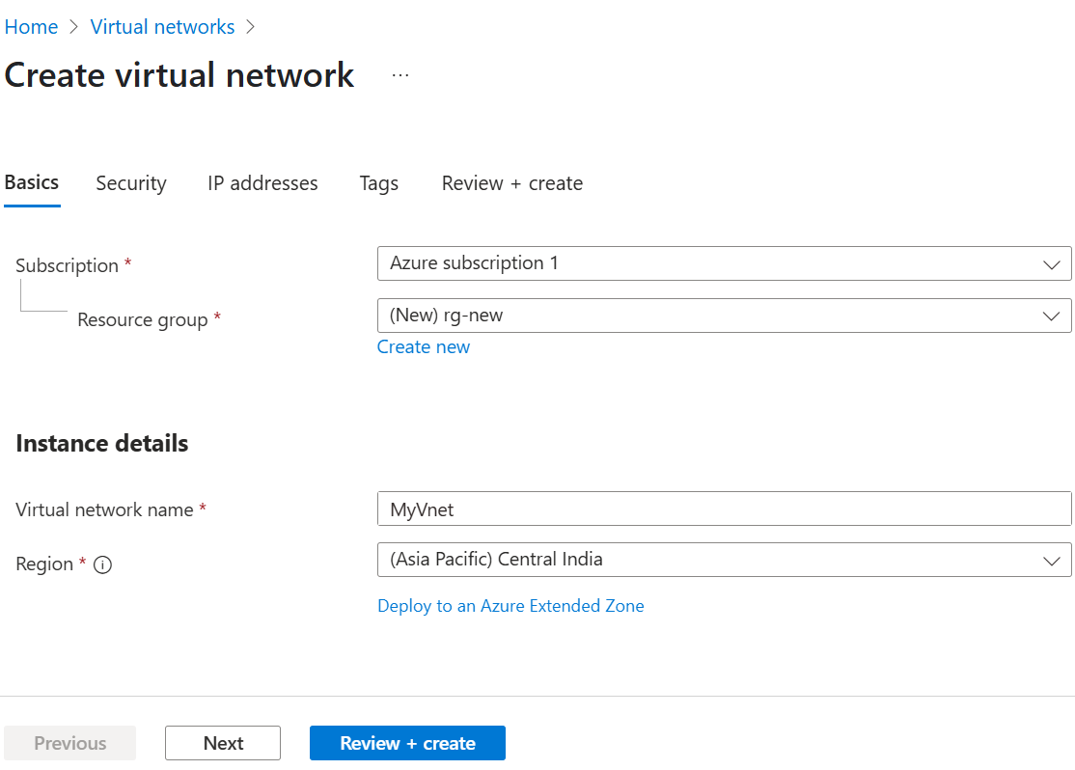
- Go to IP Addresses tab → Add two subnets:
  - PublicSubnet: 10.0.1.0/24
  - PrivateSubnet: 10.0.2.0/24 (optional)
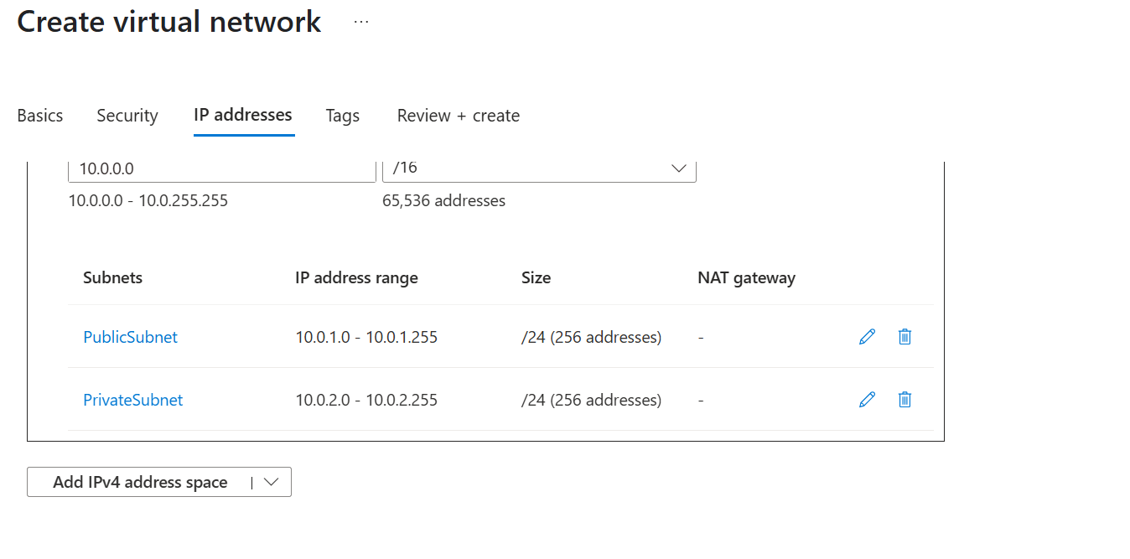
- Click Review + Create → Create
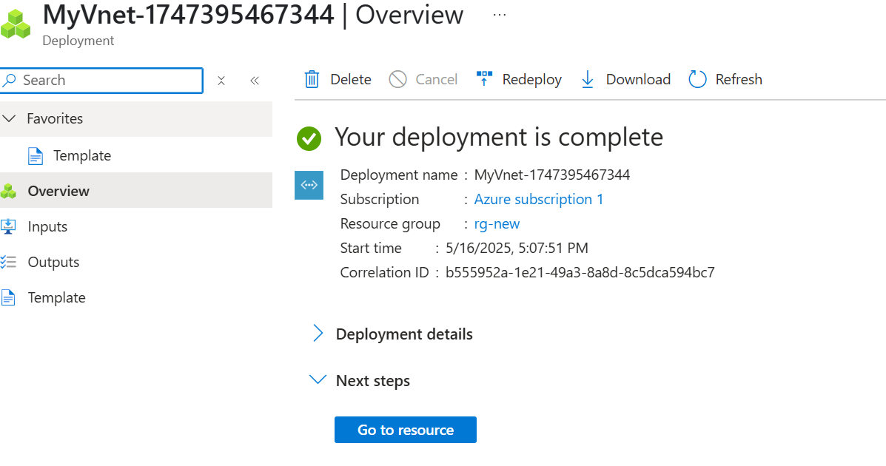
2. Create Jump VM in Public Subnet
- Go to Virtual Machines → + Create
- Name: jump-vm
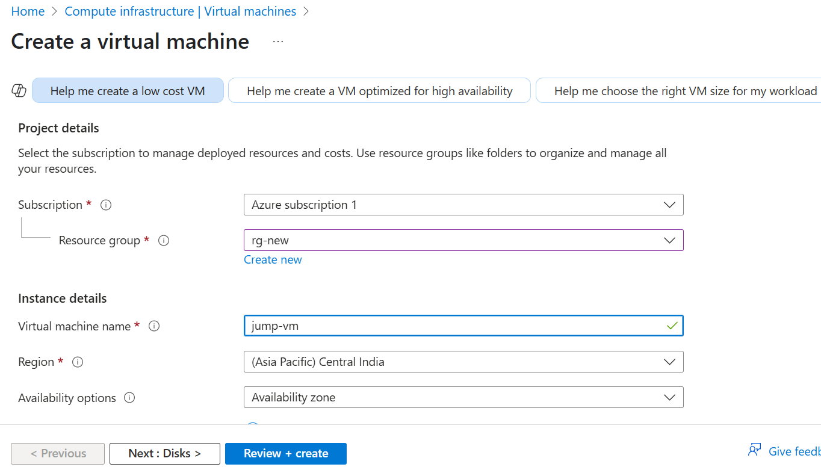
- Image: Windows Server
- Authentication: Username/password
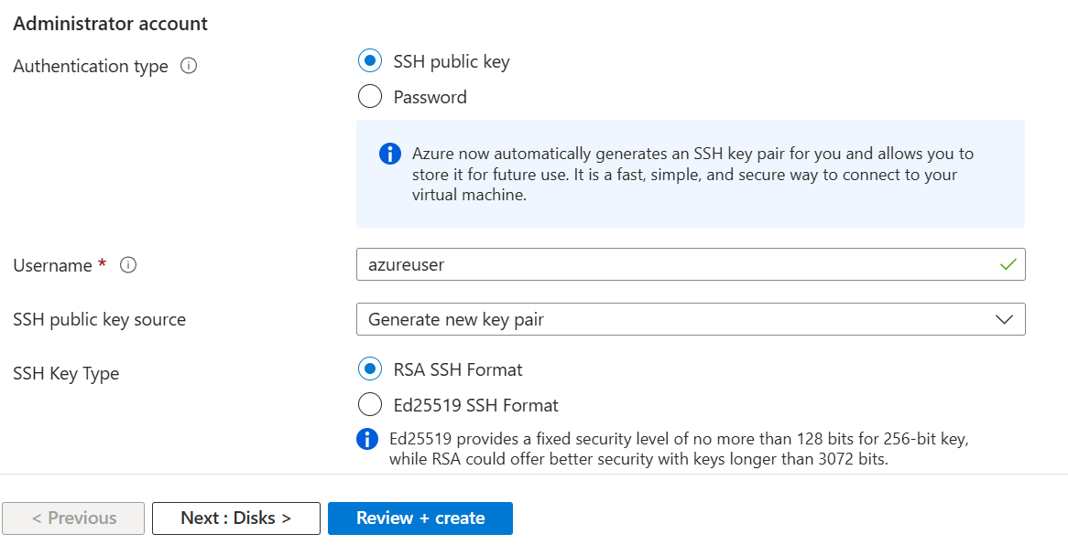
- Networking tab:
  - VNet: my-vnet
  - Subnet: PublicSubnet
  - Public IP: Yes (Static or Dynamic)
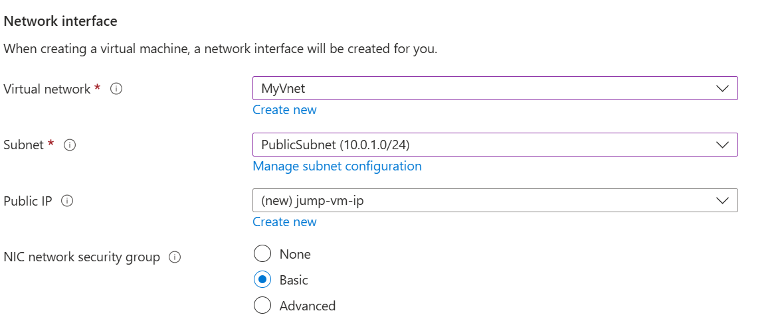
- Allow RDP (port 3389) in NSG
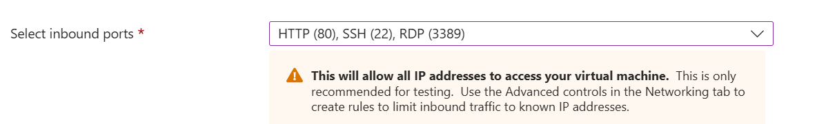
- Create the VM
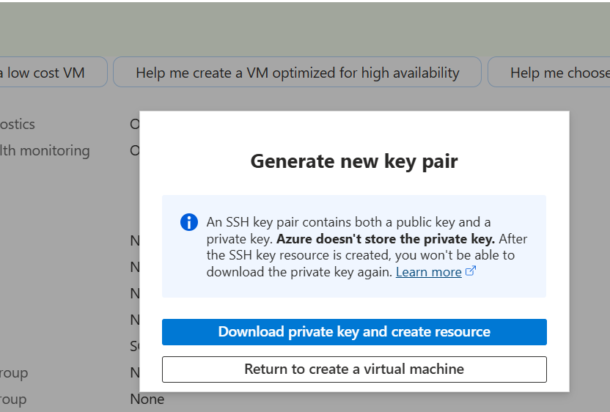

3. Create SQL Server in Public Subnet:
Azure SQL Database (PaaS) with Public Access
- Go to SQL Databases → + Create
- Choose:
  - Database name: mydb
  - Create new SQL server: my-sqlserver1
  - Location: same as your VNet
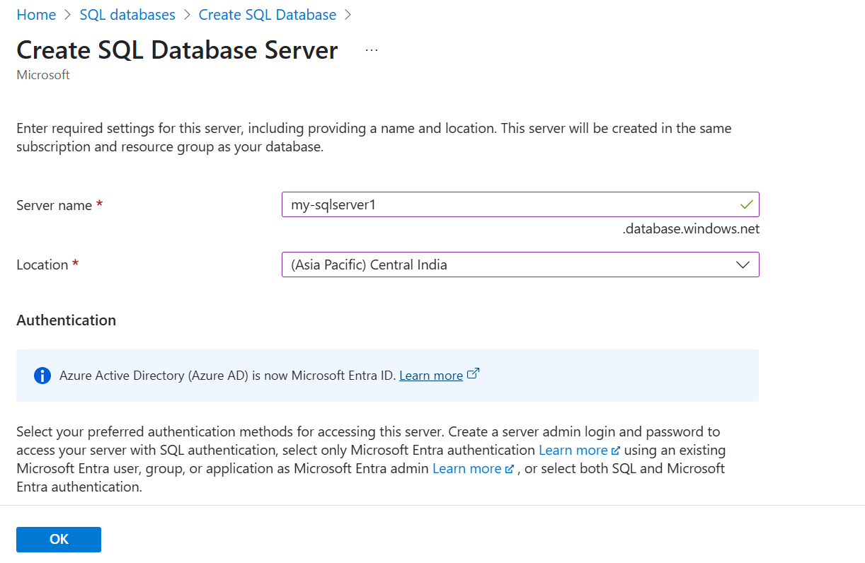
- In Networking tab:
  - Connectivity: Public endpoint
  - Allow Azure services: ✅ Yes
  - Add your client IP to firewall rule
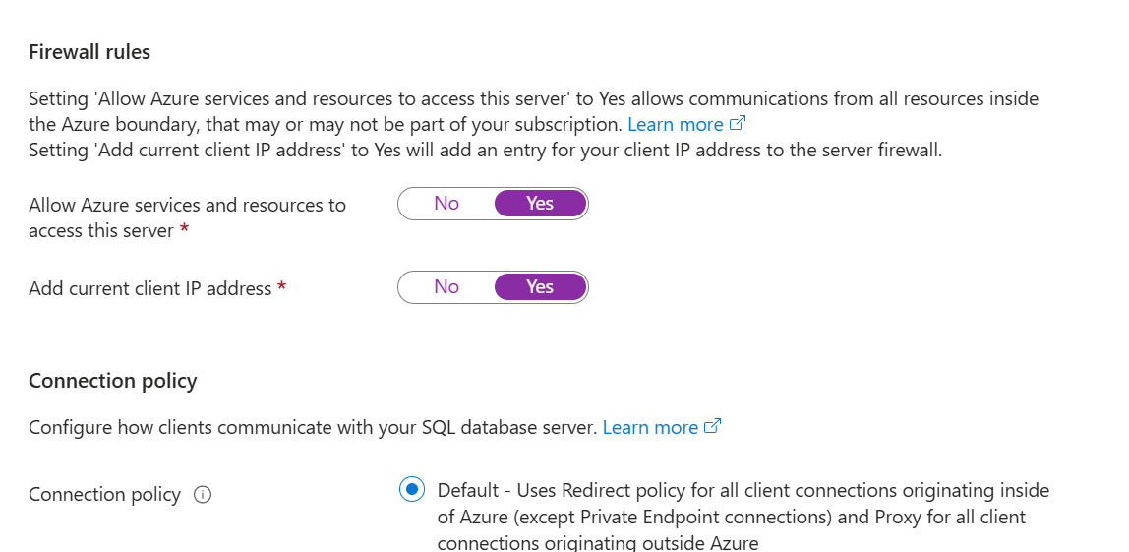
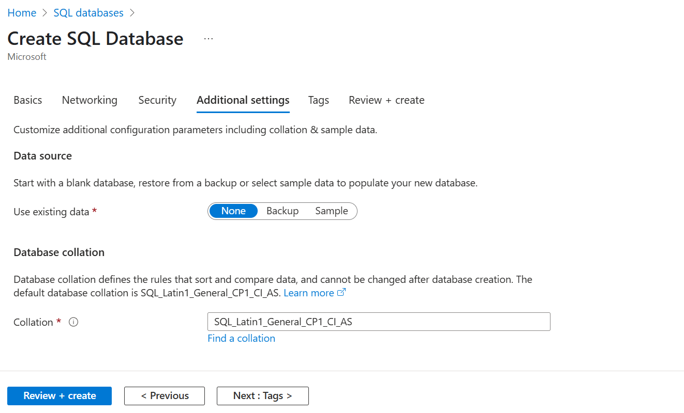
- Review + Create → Create
- Use SSMS from jump VM to connect to your server.

4. Connect with SSMS
Use one of these methods:
- From your jump VM, open SSMS and connect to:
  - SQL Server Name: Use public IP or DNS
  - Auth: SQL login or Windows Auth
- Or from your local machine, if firewall allows it.
